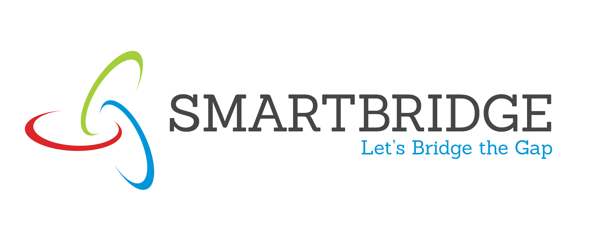 | 
Project Initialization and Planning Phase
Date | 03-07- 2026
Team ID
Project Title | OptiCrop — Smart Agricultural Production Optimization Engine
Maximum Marks | 5 Marks
Project Proposal (Proposed Solution) report
This proposal outlines OptiCrop, a machine-learning-driven tool that helps farmers, researchers, and policymakers make better crop decisions. It addresses the inefficiencies of guesswork-based crop selection by turning soil and climate readings into a data-backed recommendation, with the goal of improving yields, resource use, and long-term farming sustainability.
Project Overview
Objective | To help farmers, researchers, and policymakers make data-driven crop decisions by recommending the most suitable crop — or assessing the suitability of a chosen crop — based on soil and climate readings.
Scope | The project covers data collection and preprocessing, training a crop classification model, and delivering recommendations and suitability assessments through a simple Flask-based web application, along with a lightweight visualization dashboard for research and policy use.
Problem Statement
Description | Many farmers select crops based on tradition or guesswork rather than current soil and climate conditions, which often leads to suboptimal yields and inefficient use of resources such as water and fertilizer.
Impact | Addressing this gap can improve crop yields, reduce resource waste, and give researchers and policymakers a clearer, data-driven view of crop-environment relationships to guide sustainable agricultural strategies.
Proposed Solution
Approach | Train a Scikit-learn classification model on a crop-environment dataset (Nitrogen, Phosphorous, Potassium, temperature, humidity, pH, and rainfall) and serve it through a Flask REST API that farmers and researchers can query for recommendations and suitability checks.
Key Features | - Crop recommendation based on soil and climate readings.  - Crop suitability assessment for a user-selected crop.  - Visualization dashboard for research and policy-planning insights.  - Input validation to catch out-of-range or missing readings.
Resource Requirements
Resource Type | Description | Specification / Allocation
Hardware
Computing Resources | CPU specifications, number of cores | Intel Core i5 or above (GPU not required for classical ML models)
Memory | RAM specifications | 8 GB
Storage | Disk space for data, model, and logs | 10 GB SSD
Software
Frameworks | Python frameworks | Flask
Libraries | Additional libraries | scikit-learn, pandas, numpy, matplotlib, seaborn
Development Environment | IDE | Jupyter Notebook, VS Code
Data
Data | Source, size, format | Kaggle Crop Recommendation dataset, ~2,200 rows, csv

